 | CHAROTAR UNIVERSITY OF SCIENCE & TECHNOLOGY  DEVANG PATEL INSTITUTE OF ADVANCE TECHNOLOGY AND RESEARCH | 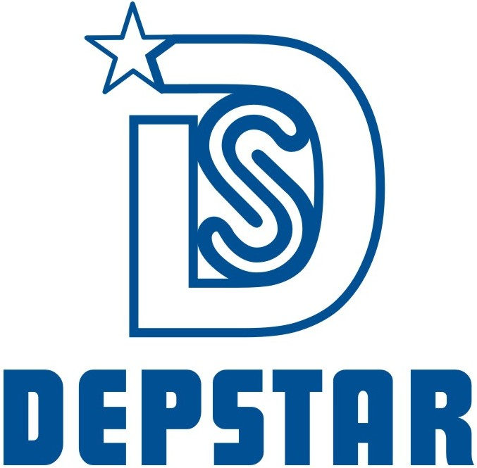

Weekly Report
In this report students require to mention the work has been done during the week and planning for the next week. (Please fill individual report for each week)

Student ID: 20DCE019 | Student Name: Yatharth Chauhan
From Date: 20/06/2022 | To Date: 25/06/2022
Semester: 5th | Internship ID:

Work done in last week (Attach supporting Documents):

Technology: UI-UX Design

Project Title: WhatsFolio Project and Nasa Industries Project

- 20/06/2022 (Monday)
Start Designing multiple screen of WhatsFolio App
- 21/06/2022 (Tuesday)
Design Nasa Industries Logo
- 22/06/2022 (Wednesday)
Design one more variation of Nasa Industries Logo and Start Redesigning Web UI of Nasa Industries
- 23/06/2022 (Thursday)
On Leave
- 24/06/2022 (Friday)
Design Modern UI of Registration Page
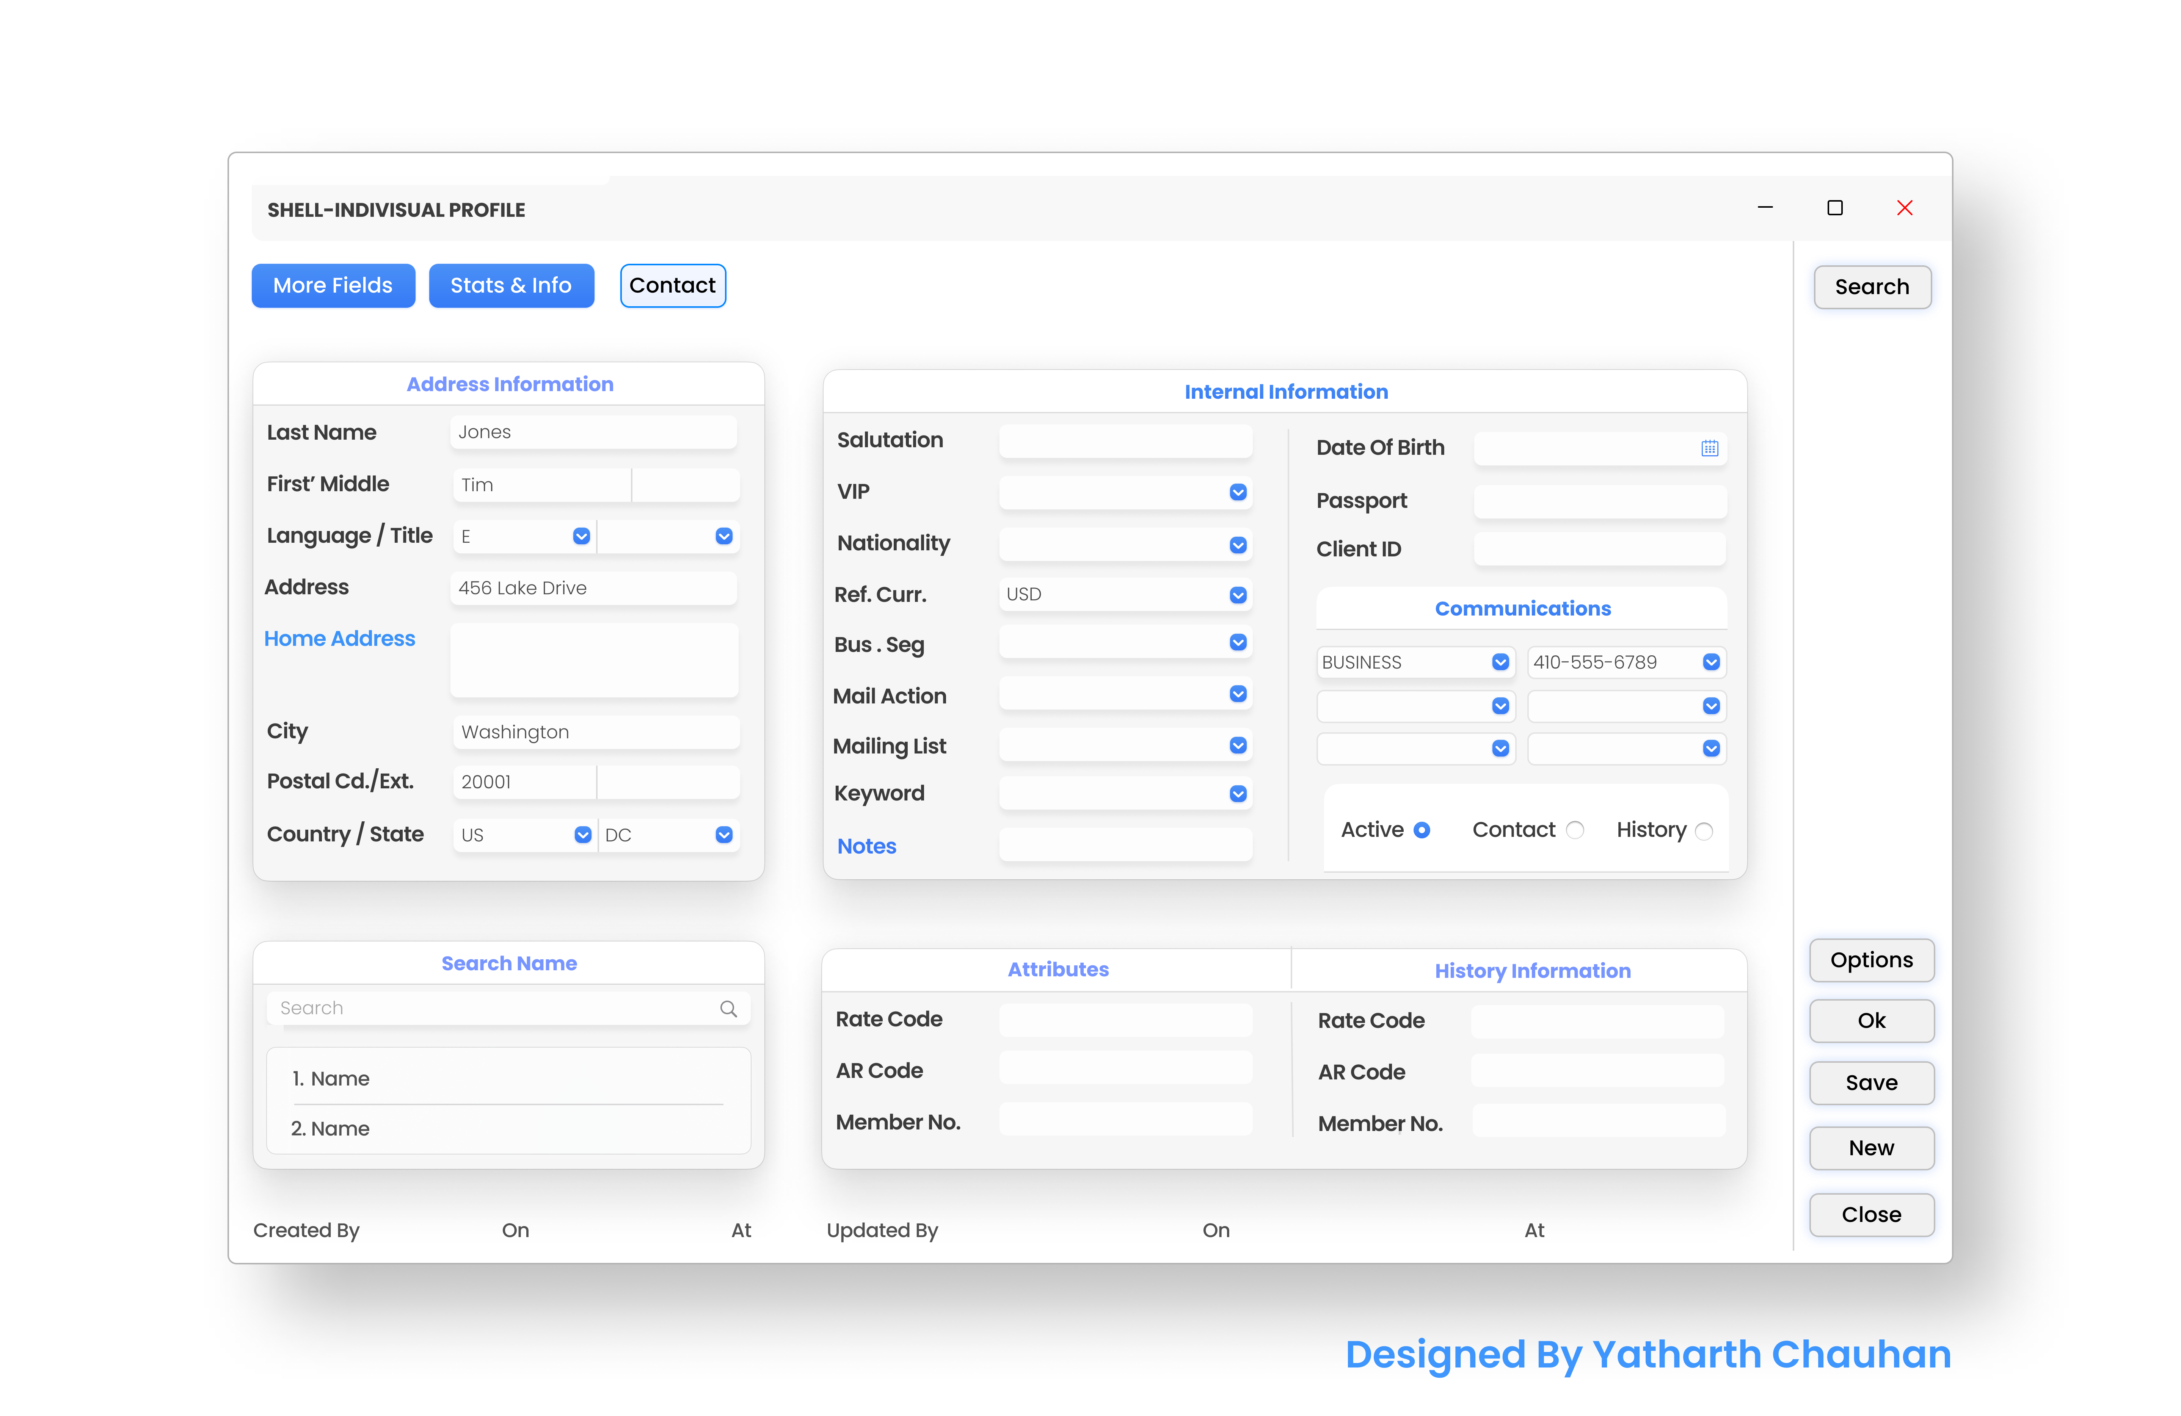
- 25/06/2022 (Saturday)
Complete Design of Modern UI of registration Page and add content and workng on Nasa Industries Project

Plans for next week:

- Nasa Industries Web Project

References:

https://marsprotocol.io/

Signature of External Guide Signature of Internal Guide

